Our vision values and aims
“I came so that they might have life and have it more abundantly.”
John 10:10

Our vision
This vision sits above every policy and decision in our school. It shapes how we teach, how we lead, how we speak to one another and how we respond when things go wrong. It is the standard we hold ourselves to as adults, and the hope we hold for every child.

What this looks like in practice
- Place Christ at the centre — helping children, families and staff to grow in a real relationship with Our Lord Jesus through prayer, worship, the Sacraments and the ordinary moments of school life.
- Pursue excellence in learning — expecting every child to work hard, think deeply and achieve highly, so that they have the knowledge and skills to serve others and shape the world for the good.
- Strive for professional excellence — as adults, we model the highest standards of conduct, punctuality, preparation and care, knowing that children learn most from what they see us do.
- Build positive professional relationships — we use words to encourage, correct with dignity and bring hope. We give one another the benefit of the doubt and address concerns directly and respectfully.
- Speak respectfully about pupils, families and colleagues, in keeping with our Catholic calling and professional standards. This includes raising concerns honestly through the appropriate channels.

Our vision in daily life
At Our Lady and St. Oswald's, every child is called to grow in virtue, knowledge and skill. Our three simple promises shape how we live, learn and treat one another every day.
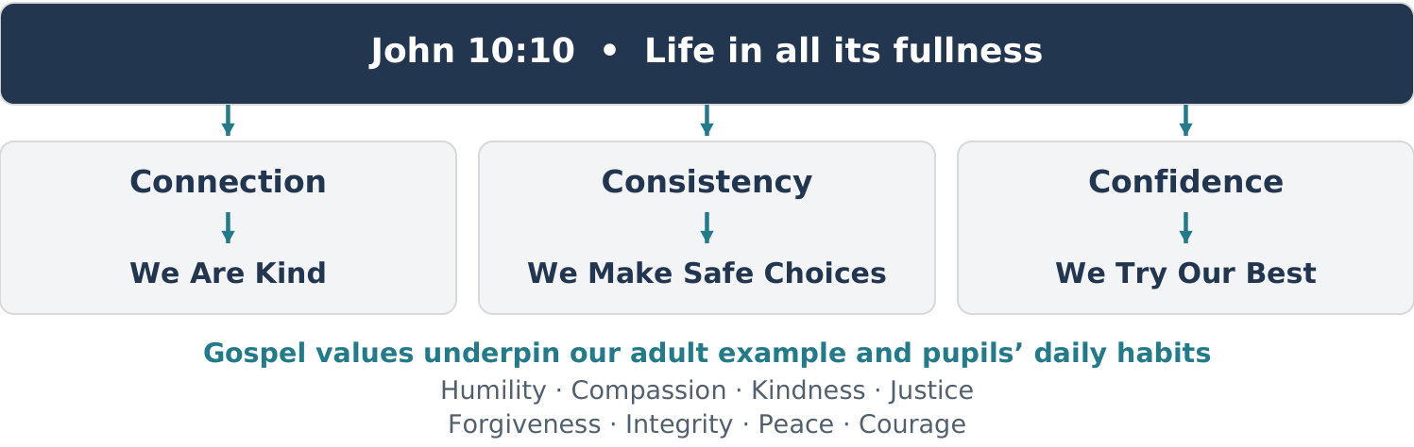

Adults model Connection, Confidence and Consistency so that children can live our school promises each day.

Our adult promises

Connection
Before we teach, redirect or challenge pupils, they need to feel a secure connection with us. Connection is the foundation of good behaviour, emotional regulation and learning.
In practice, connection means we:
- Use warmth, respect and presence — especially with the pupils who are hardest to reach.
- Offer small moments of undivided attention: greeting every pupil by name, noticing effort, and celebrating small wins.
- Stay calm and regulated when a child is not: we get to their level, acknowledge their difficulty or feelings (“I can see this is really hard right now” “I see you’re feeling angry about this”), and help them regain control.
- Repair quickly after a difficult moment — modelling humility and trust (“I shouldn’t have spoken sharply then; let’s start again”).
When children experience genuine connection, they feel safe enough to learn, brave enough to try, and open enough to accept guidance. Connection underpins our response, alongside immediate action when safety requires it.

Confidence
Confidence means we communicate, through our actions and expectations, that every pupil can grow in skills, virtues, and resilience.
In practice, confidence means we:
- Look for the skill gaps, unmet needs or barriers behind difficulties, and teach and support the child without labelling them.
- Express belief in the child even when they struggle (“I know you can do this — let’s try the first step together”).
- Support pupils to approach manageable challenges with confidence, using reasonable adjustments and agreed individual plans where needed.
- Pick one challenge point at a time and help the child build a new habit through small, repeated successes.
- Model growth by showing openness to feedback, trying new approaches, and narrating our own learning.
When pupils sense that we truly believe in their capacity for growth, they rise. Our confidence teaches them to believe in themselves.

Consistency
Consistency creates the stability children need to thrive. It reduces chaos, protects learning time, and frees up their energy for attention and self-control.
In practice, consistency means we:
- Establish predictable routines and rhythms for transitions, lessons, lining up, behaviour expectations, movement around school, and classroom norms.
- Make expectations explicit and visible so pupils always know what comes next.
- Use calm, brief reminders and the agreed 1–2–3 strategy in the Behaviour for Learning Policy. Follow through calmly, allow processing time and avoid unnecessary talk.
- Maintain consistency across adults so pupils experience the same expectations no matter who is leading.
- Use safe, proportionate consequences under the Behaviour for Learning Policy, with reasonable adjustments. Avoid repeated warnings or consequences we cannot follow through.
Consistency provides the structure; connection provides the safety; confidence provides the motivation. Together, they form a virtuous cycle that strengthens relationships, reduces anxiety, and supports excellent behaviour and learning across the school.

Our Gospel values
Jesus calls each of us to live life in all its fullness. This fuller life is lived out in the way we love God, treat one another and grow together as a school community. These values, rooted in the Beatitudes, guide our words, actions and choices.
Gospel value | The Beatitudes
Humility — seeing life as a gift | “Blessed are poor in spirit, for theirs is the kingdom of heaven.”
Compassion — showing empathy and care | “Blessed are those who mourn, for they shall be comforted.”
Kindness — showing gentleness in word and action | “Blessed are the meek, for they shall inherit the earth.”
Justice — standing up for what is right and fair | “Blessed are those who hunger and thirst for righteousness, for they shall be satisfied.”
Forgiveness — showing mercy and seeking reconciliation | “Blessed are the merciful, for they shall obtain mercy.”
Integrity — doing what is right and true | “Blessed are the pure in heart, for they shall see God.”
Peace — choosing peacemaking and non-violence | “Blessed are the peacemakers, for they shall be called children of God.”
Courage — standing up for truth and goodness | “Blessed are those who are persecuted for righteousness’ sake, for theirs is the kingdom of heaven.”

Putting our vision into practice
The Behaviour for Learning Curriculum teaches the routines and habits that help every child feel safe, calm and ready to learn: transitions, movement, listening, classroom expectations, courtesy and shared spaces. It sits alongside the Behaviour for Learning Policy.
Before lunch each day, classes review and practise one aspect for 15 minutes, adapted to pupils’ ages and needs. Adults model the same standards, recognise progress and help pupils practise again when needed.

Our shared high standards
The detailed shared expectations remain subject to staff review and agreement. The Behaviour for Learning Curriculum records the routines for that discussion; this review does not introduce an additional set of non-negotiables.
Related document — Behaviour for Learning Curriculum

